

|  |  |
| --- | --- |
|  | **Shutterfly Google Drive Migration**  Migration plan  Prepared For  Shutterfly  Prepared By  Rabiah Memon, Sr. Solutions Architect  Version 1.0 |

# Revision History

|  |  |  |
| --- | --- | --- |
| Date | Author | Description |
| 5/9/2022 | Rabiah Memon | Draft 1 complete |
| 5/10/2022 | Rabiah Memon | Draft 1 review with client |
|  |  |  |
|  |  |  |
|  |  |  |
|  |  |  |
|  |  |  |

Table of Contents

Revision History 2

Introduction 8

Document Purpose 8

Pre-requisites 8

Migration mapping plan 9

Google Drive content for User Files 9

Google Drive content for iHub 10

Google Drive content for Shared Google Drives 11

Overall Migration Approach 12

Google Content Migration - Challenges and Remediation 13

Embedded Links 14

Description 14

Remediation 14

Special/Unsupported characters in folder/file name 14

Description: 14

Remediation 14

Storage Capacity 14

Description 14

Remediation 15

File size for Google Apps 15

Description 15

Remediation 15

Google Workspace data in Google Drive 15

Description 15

Remediation 15

Maximum number of files per folder 5000 15

Description 15

Remediation 16

Shared Links 16

Description 16

Remediation 16

Maintain Sharing permissions during migration 16

Description 16

Remediation 16

External Sharing Permissions 16

Description 16

Existing processes, automations, and integration 17

Description 17

Remediation 17

Ability to sync all files locally to desktops. 17

Description 17

Remediation 17

Invalid File Names 17

Description 17

Remediation 17

Libraries/Lists/Folder with over 100k items 18

Description 18

Remediation 18

Migration Tasks 18

Sky Sync Installation 18

SkySync Server Specifications 18

Configure Office 365 Tenant 18

Provision users in Office 365 and Assign licenses 18

Provision OneDrive 18

Initial Assessment 19

Validate that there are no username collisions between migrating users and Target tenant 19

Document SharePoint settings in Target tenant. 19

Document Teams settings in Target tenant. 19

Review resources in scope for migration 19

Provision Required Access 19

Request required permissions 19

Register for SkySync account (Service account) 19

Provide Office 365 permissions (Service account) 19

Provide tool permissions (SkySync account) to Source and Destination 19

Finalize Migration Groups (Migration "waves") 20

Provision Shutterfly SharePoint Site 20

LifeTouch in SPO - UAT and Bug Fixing 20

Optimize and Configure SkySync for Migration Jobs 20

SPO / OneDrive / Teams Proof of Concept Migration 20

Pre-create SharePoint sites in Target tenant 20

Validate OneDrive sites in Target tenant 20

Pre-create Teams sites in Target tenant 20

Enable SharePoint site features in Target tenant 20

Pre-create SharePoint site structure in Target tenant 21

Pre-create Teams site structure in Target tenant 21

Migrate POC SharePoint data 21

Migrate POC OneDrive data 21

Migrate POC Teams data 21

Analyze SharePoint results and resolve errors 21

Analyze OneDrive results and resolve errors 21

Analyze Teams results and resolve errors 21

Finalize Communication Plan 21

Develop end user communication plan / timeline 22

Create end user communication template 22

Verify migration group CSV/Excel file 22

SPO / OneDrive / Teams Pre-stage for Pilot 22

Pre-create SharePoint sites in Target tenant for pilot 22

Pre-create Teams sites in Target tenant for pilot 22

Enable SharePoint site features in Target tenant for pilot 22

Pre-create SharePoint site structure in Target tenant for pilot 22

Pre-Provision OneDrive site in Target tenant for pilot 22

Pre-create Teams site structure in Target tenant for pilot 22

Pre-stage pilot SharePoint 22

Pre-stage pilot OneDrive 23

Pre-stage pilot Teams 23

SPO / OneDrive / Teams Full Pre-stage *In Waves* 23

Pre-create SharePoint sites in Target tenant for remaining content 23

Validate OneDrive sites in Target tenant for remaining users 23

Pre-create Teams sites in Target tenant for remaining users 23

Enable SharePoint site features in Target tenant for remaining content 23

Pre-create SharePoint site structure in Target tenant for remaining iHub content 23

Pre-create Teams site structure in Target tenant for remaining Shared Drives 23

Pre-stage remaining SharePoint content 23

Pre-stage remaining OneDrive content 23

Pre-stage remaining Teams content 23

Smoke testing/initial QA for remaining users’ content 24

Pilot Migration 24

Send end user communication 24

Migration simulation and migration of content 24

Review logs and document lessons learned 24

Pilot Delta Migration 24

Validate SharePoint / OneDrive /Teams Sync 24

Provide post-migration support 24

Full Migration Go / No-Go 24

Document pilot issues and lessons learned 24

Discuss pilot results and lessons learned 24

Make go / no-go determination for full migration 25

Full Migration Preparation 25

Send end user communication 25

Google Drive to SPO / OneDrive / Teams Full migration 25

Send migration start update 25

User acceptance testing (UAT). 25

Delta migration for SharePoint lists 25

Delta migration for Teams lists 25

Validate SharePoint Sync 25

Validate OneDrive Sync 26

Validate Teams Sync 26

Google Drive /iHub Cutover 26

Test SPO/OneDrive/Teams content 26

Send migration completion update 26

G-Drive/OneDrive cutover 26

Post-Cutover Support 26

Migration Decision Tracker 27

Roadmap/Out of Scope 28

# Introduction

Shutterfly, LLC. is an American photography, photography products, and image sharing company, headquartered in Redwood City, California. Shutterfly has contacted Affirma to help with migrating the data from Google Drive into SharePoint and OneDrive, as well as building a replacement for the Google Site iHub in SharePoint Online.

The Affirma project team has gathered requirements and will plan and execute the migration of content to Microsoft 365.

# Document Purpose

This document serves as the plan to migrate Shutterfly’s current Google content to M365. The purpose of this document is to provide insight into the process and methods to ensure a successful migration.

# Pre-requisites

Below are the pre-requisites to migrate content from Google tenant to Microsoft. The requirements listed below are instrumental in ensuring a successful migration. The table below lists the pre-requisites and a status of whether the requirement was completed during the planning phase.

|  |  |
| --- | --- |
| Pre-requisite | Status |
| A complete content inventory is performed to discover content for migration of Google Drive. | Completed |
| A complete content inventory if performed to discovery content for migration of iHub. | Completed. |
| All content included in this inventory analysis has been verified as relevant by key project stakeholders. | Pending approval |
| All users that will be migrated are marked for migration. | Pending approval |
| All users that will be migrated have been assigned credentials and licenses in Microsoft 365. | Pending |
| All users that are being migrated have OneDrive provisioned. | Pending |
| SharePoint sites have been provisioned for iHub migration. | Pending |
| All inventoried content from G-Suite has been mapped to locations in the Microsoft tenant and approved by project stakeholders | Pending Approval |
| SkySync migration tool has been purchased. | Pending |
| Virtual servers that will host SkySync migration tools have been architected. | Pending |
| SkySync tool has been installed. | Pending |
| Communication plans have been established. | Pending |
| Access has been granted to Affirma team | Completed |
| Confirm that the data that is older than June 2019 does not need to be migrated. | Pending Approval |

# Migration mapping plan

The migration map builds a relationship between the migration source content (Google Drive) and the destination (O365), showing where content will be moved to during migration.

The goal of the migration mapping is to provide a logical system for moving the content efficiently and effectively into Office 365. Because this migration is a “lift-and-shift” type migration (i.e., the content will move mostly as-is without a major restructuring of folders), this mapping will primarily show how large portions of content (i.e., not granular level content) will be moved.

Additionally, this mapping is mostly logical, meaning that there is no exact mapping of each file and folder from source to destination. Instead, logical rules are here described for moving all content. These rules will be followed by the Affirma and Shutterfly Migration team.

## Google Drive content for User Files

To migrate content from Google Drive user content to OneDrive, there are two approaches:

1. Migrate content by drive ownership.
2. Migrate content by file ownership.

Although Affirma team had initially recommended that the data should be migrated by “Drive owner”, Shutterfly team has decided to move data by file ownership. This would mean every user’s data will be migrated to their respective OneDrive, as long as the user has the ownership of the data regardless of where that data is located.

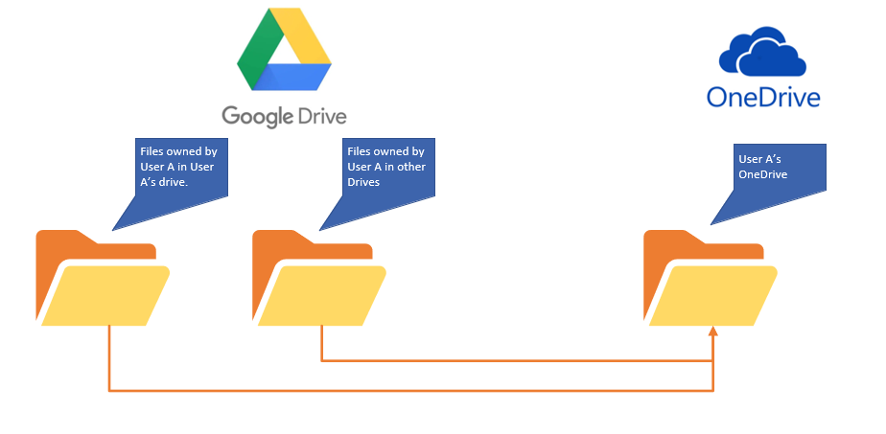

This creates some challenges as users often have files in their drive that are owned by other users and not necessarily the drive owner. As for remediation and making sure users have a smooth transition, an established communication plan will need to ensure that these changes are being communicated to the end users and users are encouraged to take ownership of the files that they want to retain in their drive during the migration effort.

A detailed list of user mapping has been provided here.

## Google Drive content for iHub

For iHub, the content will be migrated from Google Drives to root site of the LifeTouch photography Hub and the member sites on SharePoint Online.

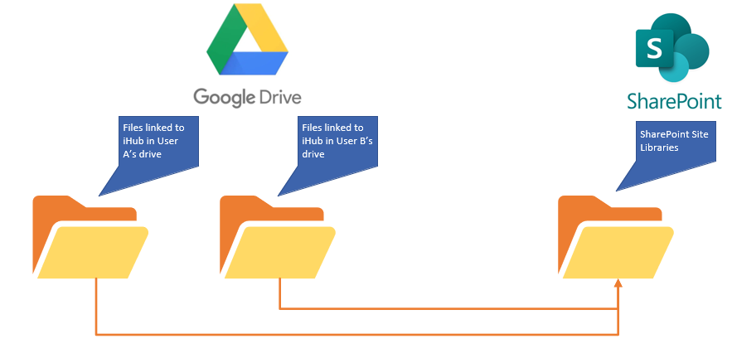

Refer to iHub mapping and Functional specification documentation [here](https://shutterfly.sharepoint.com/:f:/r/sites/AffirmaDataAssessment/Shared%20Documents/General/Migration%20Planning?csf=1&web=1&e=oNjXB5) for details.

## Google Drive content for Territory Google Drives

For Shared Drives that are shared by departments or multiple users, the content will be migrated to their own “Teams” sites. A team site will be created for each Shared Drive that will be attached to Microsoft Teams.

Updates made: Territory drives will be migrated to SPO, not Teams.

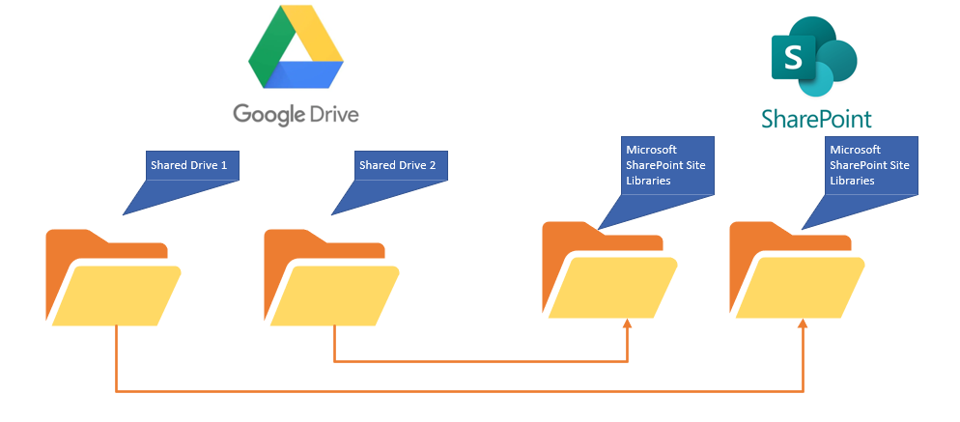

# Overall Migration Approach

Overall migration approach will be thoroughly tested after the SkySync installation has been completed. Several POC (proof of concept) or test migrations will be performed using test data sets to determine the velocity and bandwidth. After the test migrations have been completed, a pilot group will be identified for production migration. After a successful migration of the pilot group, results and lessons learned will be documented and migration waves will start for the rest of the users.

During the migration, the data will be pre-staged where sync jobs will be created in SkySync. After the

# Google Content Migration - Challenges and Remediation

The Section below describes the known challenges with migrating data from Google Drives to Office 365. For each challenge a "Remediation" plan is listed. The goal of this section is to help understand the challenges and being prepared for the migration.

The migration challenges are broken-down into these categories:

* Storage - Relating to storage space limitations.
* Permissions - Preserving permissions and access to files and folders.
* Integration - Where other systems are integrated with G-Drive data.
* Data Compatibility - Whether the destination (O365) supports the paths, names, and types of data.
* User Experience - Challenges with providing a comparable or improved user experience in the destination (O365).

## Embedded Links

Challenge Category: Integration

### Description

Embedded links are found in google documents for the end users, as well as other integrated systems such as Confluence and Jira.

### Remediation

For embedded links in user documents, communication will be sent out to ensure that users are updating the links. Jira/Confluence are still pending Shutterfly’s decision. Although Jira/Confluence updates are out of scope, Affirma team can assist in the next phase after the migration as needed and it is recommended that the changes are made soon after the migration while the content is still in Google drive.

## Special/Unsupported characters in folder/file name

Challenge Category: Data Compatibility

### Description:

In Google Drive, files may have unique/special characters in the file and folder names (e.g. * , ? , < , >) which may be unsupported in the O365. These files/folders need to be migrated to O365.

O365 does not support storing files/folders with certain unsupported characters in the file/folder name; these include / , | , \ , \\ , / , : , * , ? , < , >

### Remediation

SkySync, the migration tool of choice, has a Segment Transformation policy feature; when enabled it will automatically transform unsupported characters to a supported underscore character. If for any reason the SkySync “Segment Transformation” policy is not 100% effective, any issue with a file/folder will be automatically flagged during migration by SkySync and can be manually remedied and migrated later.

## Storage Capacity

Challenge Category: Storage

### Description

In O365, the total storage per organization is 1 TB plus 10 GB per license purchase for SharePoint, and OneDrive storage is limited to 1 TB per user. Currently, the total storage in SPO storage in Shutterfly Tenant that is available is ~24 TB. There are 23 users that have over 1 TB of data in their drives.

### Remediation

Both teams will need to closely monitor the storage capacity and enough O365 licenses will need to be in place to allow for enough storage space for the entire organization. For example, for each user a “Office 365 Extra File Storage” add-on subscriptions can also be added if needed for the drives that contain over 1 TB of data. Additionally, come files can also be archived and deleted.

## File size for Google Apps

Challenge Category: Storage

### Description

File size for Google apps data that is in scope for migration is unavailable through the API. This includes Google sheet, docs, and presentation data. This creates an additional risk where the migration team will not know upfront the size of the data from those applications.

### Remediation

SkySync will convert those files into a format that is supported by Microsoft (For example, Google Sheets will be converted to a downloadable excel file prior to migration) and the migration team will need to closely monitor the space required and communicate if additional space is needed to migrate the google apps content.

## Google Workspace data in Google Drive

Challenge Category: User experience

### Description

A user has the ability to view most of their google apps data in Google Drive. Any custom apps that they may have created, or any forms that they have created or own show up in the google drive. Those types of data will not be migrated during the project.

### Remediation

It is recommended that the user communication covers this issue, as forms/apps will need to be recreated in Microsoft tenant by the end users as needed.

## Maximum number of files per folder 5000

Challenge Category: Data compatibility

### Description

While a folder in O365 can contain up to 30 million files, each folder should not have more than 5000 child items (not counting the contents of subfolders); any items beyond the 5000 limits cannot be viewed in SharePoint.

### Remediation

This challenge does not affect the migration; the migration will successfully complete. But the issue affects how files will be viewed and accessed in O356. If a folder contains more than 5000 child items, it can be split up into multiple folders after the migration. Custom views can also be created to remedy this.

## Shared Links

Category: Permissions

### Description

In Google Drive, "Shared Links" are generated and sent to employees and external users. These links are used to grant permission and access a file or folder in Google Drive.

If a user was given an external sharing link to access a file or folder in Google Drive, this link will no longer work for accessing the file/folder after migration unless the link has been replaced with a new O365 shared link (see section about "Embedded Links" above).

### Remediation

Shared links can be migrated to O365 from Google using SkySync However, the new link in O365 is a new unique URL; the old Google Shared Links will no longer work unless they have been replaced (with the new link URL) either by automation by updating the links automatically in a system such as JIRA (see "Embedded Links" section) or manually updated by users.

## Maintain Sharing permissions during migration

Category: Permissions

### Description

In Google Drive, folders and files are shared with other Shutterfly employees who need the same access in O365 to the same files/folders. In O365, the destination locations of migrated files and folders may be in OneDrive or SharePoint.

### Remediation

SkySync, the migration tool of choices, will preserve file and folder permissions during migration.

## External Sharing Permissions

Category: Permissions

### Description

In google drive, users have the ability to share items with external users, including vendors/partners etc.   
Remediation

SkySync, the migration tool of choice, will migrate the external access permissions for files/folders to O365 when External Permissions Passthrough is enabled (see here); however, only an “Invitation” in O365 is generated by SkySync and site admins must review and resend the invites to the external users. Once they have accepted the invite, the access will be granted.

## Existing processes, automations, and integration

Category: Integration

### Description

One of the challenges of migrating the content from one cloud solution to another is with regards to the existing processes, automation, and integration with other applications and tools and there is always a risk that a user maybe relying on a certain process where either an automation or an integration is taking place.

### Remediation

During the discovery phase, Shutterfly team has confirmed with Affirma team that no automation or integration of any sort is taking place with existing Google Drive. User communication should include information about custom automation or integration just in case.

## Ability to sync all files locally to desktops.

Category: User experience

### Description

Google Drive allows users to sync their files from GDrive to their desktop, Users will need to sync files from O365 to their local desktop.

### Remediation

O365 provides a very similar ability to Google Drive for synching files to your desktop. Through the OneDrive synchronization tool files can be synced from SharePoint and OneDrive.

## Invalid File Names

Category: Data incompatibility

### Description

In O365, stored files cannot have leading white space or trailing periods and white-space. However, if a file extension is present, trailing periods and white-space are allowed before the extension. Additionally, file names cannot have non-printable ASCII characters.

### Remediation

These types of cases should be rare, but in the event a file name has one of these issue, our pre-migration check (i.e., SkySync Simulation mode) will find files with this issue. Our plan is to manually update any problematic file name that is found during our check before migrating.

## Libraries/Lists/Folder with over 100k items

Challenge Category: Data compatibility

### Description

While a folder in O365 can contain up to 30 million files, when a list, library, or folder contains more than 100,000 items, you can't break permissions inheritance on the list, library, or folder. You also can't re-inherit permissions on it

### Remediation

This challenge does not affect the migration; the migration will successfully complete. But it will impact how the permissions are applied. For those libraries/lists/folders that have over 100k items, permissions need to be applied on the parent.

## Libraries/Lists/Folder with over 10k child items

Challenge Category: Data compatibility

### Description

SkySync has a limitation for migration that limits us to 10K items per folder.

### Remediation

Restructure those items that contain over 10K items. SkySync will flag drives that have more than 10K items.

## Unable to efficiently accommodate different retention policies for different MimeType/File types

Challenge Category: Data compatibility

### Description

No efficient way to apply different retention policies for file types, it would require separate jobs to be created.

### Remediation

Apply same retention policy for all file types.

## Reporting data not available for certain file types that belong to Google Apps

Challenge Category: Data compatibility

### Description

Google Drive does not give us size information for files that are for Google Apps (Google Docs/Google Sheets files for example)

### Remediation

While the size reporting would not be available for those file types, SkySync will convert them into Microsoft compatible files. The team would need to keep an eye on the storage and how those files may impact the overall storage allowed for each user.

# Migration Tasks

## Sky Sync Installation

As a pre-requisite, SkySync tool will be configured on virtual servers hosted in Shutterfly’s Azure tenant. Affirma team will need the servers to be connected to the same network and will require local admin access on all servers. SQL license will be required for one of the servers that will serve as the primary database server for SkySync.

## SkySync Server Specifications

TBD – will be provided before the SkySync installation process.

## Configure Office 365 Tenant

Office 365 tenant is already setup for Shutterfly tenant. Currently, the OneDrive is setup to receive 3 TB of data per licensed user, and SharePoint has ~24 TB of storage available. Shutterfly’s SPO admin center can be accessed by visiting <https://shutterfly-admin.sharepoint.com/>.

### Provision users in Office 365 and Assign licenses

Users will need to be provisioned in Microsoft 365 tenant and will need to have proper licensed assigned to be able to access OneDrive and SharePoint Online.

### Provision OneDrive

OneDrive accounts will need to be provisioned for all licensed users that are being migrated from Google Drive to OneDrive.

## Initial Assessment

Prior to the migration, an Initial assessment will be performed using SkySync to validate there are no issues that need to be remedied prior to the migration.

Note: Challenges that may come up during the migration are documented in the migration challenges and remediation section of this document. The purpose of the initial assessment is to ensure that the migration jobs flow smoothly across the tenant.

### Validate that there are no username collisions between migrating users and Target tenant

SkySync initial assessment will validate that there are no username collisions between migrating users and target tenant.

### Document SharePoint settings in Target tenant.

SharePoint settings in target tenant will be documented prior to the migration. Screenshots will be taken, and any topics around best practices maybe brought up to Shutterfly team.

### Document Teams settings in Target tenant.

Teams’ settings will be documented in Shutterfly tenant for any sites that are connected to MS Teams.

### Review resources in scope for migration

All files that are hosted in Google drive will be eligible for migration and supported by Microsoft 365. Forms and Apps will be out of scope for this migration. Prior to the migration, resources will be reviewed by the migration team.

## Provision Required Access

Throughout the course of migration, Affirma team will need continued admin access to the resources in both source and target tenants.

### Request required permissions

Any specific permissions required to carry out migration tasks will be requested by Affirma team.

### Register for SkySync account (Service account)

A service account will need to be created for SkySync migration and Affirma team will need access to it. as well as Global admin rights in Microsoft 365. The service account will need to be licensed in both Google and Microsoft Tenants.

### Provide Office 365 permissions (Service account)

The SkySync service account will need Global admin rights in target Microsoft Tenant.

### Provide tool permissions (SkySync account) to Source and Destination

SkySync account will need rights to OneDrive accounts as well as Google accounts and SharePoint sites.

## Finalize Migration Groups (Migration "waves")

Affirma and Shutterfly teams will decide which users will be included in each Migration wave. It is recommended that the users with least amount of data are migrated first, and users with no data are eliminated from the migration.

## Provision Shutterfly SharePoint Site

The site will need to be provisioned for LifeTouch photography that is replacing iHub. The site will need to be designed and implemented according to the Functional Specifications and Designs created by Affirma team. Quality assurance testing will need to be performed by Affirma team.

## LifeTouch in SPO - UAT and Bug Fixing

Shutterfly team will need to test the SharePoint Online site using the “UAT” or “User Acceptance Testing” plan and report bugs. Affirma team will resolve any bugs that are reported.

## Optimize and Configure SkySync for Migration Jobs

Affirma team will optimize and configure SkySync for migration job creation to ensure migration tasks are completed smoothly.

## SPO / OneDrive / Teams Proof of Concept Migration

Proof of concept or test migration will be performed on multiple sets of data that will be migrated to SharePoint Online, OneDrive, and Teams. The purpose of the POC/Test migration is to catch any issues that may come up before the migration that need to be remedied and study the velocity and bandwidth of the migration jobs. Although very rare, there could be instances after the test/POC migration where an architectural change may be required to accommodate a large set of migration.

### Pre-create SharePoint sites in Target tenant

Sites will need to be pre-provisioned in target tenant for iHub POC/Test migration. Permissions will need to be assigned for Shutterfly and Affirma team members.

### Validate OneDrive sites in Target tenant

OneDrive sites will need to be validated in the target tenant for POC/Test migration. Permissions will need to be granted to the SkySync service account to perform migration.

### Pre-create Teams sites in Target tenant

Team sites will need to be provisioned in target tenant to perform POC/Test migration for shared drives.

### Enable SharePoint site features in Target tenant

Recommended site features will be enabled in Target tenant for SharePoint site.

### Pre-create SharePoint site structure in Target tenant

SharePoint site structure will be created in target tenant for iHub sites POC migration.

### Pre-create Teams site structure in Target tenant

Teams site structure will be created in target tenant to host Shared Drive content. The structure will be out of the box, with all the content residing in the “General” folders in the document library.

### Migrate POC SharePoint data

Affirma team will perform a proof of concept/test migration of the Google Drive data that needs to be migrated to SharePoint Online.

### Migrate POC OneDrive data

Affirma team will perform a proof of concept/test migration of the Google Drive data that needs to be migrated to OneDrive.

### Migrate POC Teams data

Affirma team will perform a proof of concept/test migration of the “Shared” Google Drive data that needs to be migrated to Teams.

### Analyze SharePoint results and resolve errors

Affirma team will review logs and analyze results from the SharePoint migration and resolve and document any errors and issues and create a plan to ensure that those errors do not happen during the migration of user data.

### Analyze OneDrive results and resolve errors

Affirma team will review logs and analyze results from the OneDrive migration and resolve and document any errors and issues and create a plan to ensure that those errors do not happen during the migration of user data.

### Analyze Teams results and resolve errors

Affirma team will review logs and analyze results from the Teams migration and resolve and document any errors and issues and create a plan to ensure that those errors do not happen during the migration of user data.

## Finalize Communication Plan

Shutterfly team will finalize the communication plan and update the migration team.

### Develop end user communication plan / timeline

Timeline will be created for user communication by Shutterfly team to ensure users stay up to date on how the migration is progressing and what is expected before, during, and after the migration.

### Create end user communication template

Shutterfly team will create end user communication template that will be utilized throughout the course of the migration to communicate changes and updates.

### Verify migration group CSV/Excel file

Shutterfly and Affirma migration team will verify and review migration groups for each wave for the migration.

## SPO / OneDrive / Teams Pre-stage for Pilot

For Google Drive content migration that has a critical deadline, it is recommended that the content is pre-staged in SkySync. This allows us to pre-create jobs, regardless of “when” the actual migration occurs, and ensures that the team continues to make progress as other details are being finalized (such as migration groups/waves, etc.). For Pilot, all users that are identified to participate will have their data pre-staged.

### Pre-create SharePoint sites in Target tenant for pilot

Sites will need to be pre-provisioned in target tenant for iHub pilot migration. Permissions will need to be assigned for Shutterfly and Affirma team members.

### Pre-create Teams sites in Target tenant for pilot

Team sites will need to be provisioned in target tenant to perform Pilot migration for shared drives.

### Enable SharePoint site features in Target tenant for pilot

Recommended site features will be enabled in Target tenant for SharePoint site.

### Pre-create SharePoint site structure in Target tenant for pilot

SharePoint site structure will be created in target tenant for pilot group, this includes any lists/libraries and pages.

### Pre-Provision OneDrive site in Target tenant for pilot

OneDrive sites will need to be validated in the target tenant for pilot migration. Permissions will need to be granted to the SkySync service account to perform migration.

### Pre-create Teams site structure in Target tenant for pilot

Teams site structure will be created in target tenant to host Shared Drive content. The structure will be out of the box, with all the content residing in the “General” folders in the document library.

### Pre-stage pilot SharePoint

Jobs will be created for all data that has been identified for Pilot iHub group.

### Pre-stage pilot OneDrive

Jobs will be created for all data that has been identified for Pilot OneDrive group.

### Pre-stage pilot Teams

Jobs will be created for all data that has been identified for Pilot Teams group.

## SPO / OneDrive / Teams Full Pre-stage *In Waves*

All content will be pre-staged in SkySync for migration preparation. User groups will be identified for each wave, and it is recommended that the users with least amount of data are prioritized to reduce the job load on the servers.

### Pre-create SharePoint sites in Target tenant for remaining content

Sites will need to be pre-provisioned in target tenant for iHub migration. Permissions will need to be assigned for Shutterfly and Affirma team members.

### Validate OneDrive sites in Target tenant for remaining users

OneDrive sites will need to be validated in the target tenant for pilot migration. Permissions will need to be granted to the SkySync service account to perform migration.

### Pre-create Teams sites in Target tenant for remaining users

Team sites will need to be provisioned in target tenant to perform migration for shared drives.

### Enable SharePoint site features in Target tenant for remaining content

Recommended site features will be enabled in Target tenant for SharePoint site.

### Pre-create SharePoint site structure in Target tenant for remaining iHub content

SharePoint site structure will be created in target tenant for full migration of iHub content, this includes any lists/libraries and pages.

### Pre-create Teams site structure in Target tenant for remaining Shared Drives

Teams site structure will be created in target tenant to host Shared Drive content. The structure will be out of the box, with all the content residing in the “General” folders in the document library.

### Pre-stage remaining SharePoint content

Jobs will be created for all data that has been identified for iHub content migration.

### Pre-stage remaining OneDrive content

Jobs will be created for all users (in waves) that have been identified for OneDrive migration.

### Pre-stage remaining Teams content

Jobs will be created for all data that has been identified for Pilot Teams group.

### Smoke testing/initial QA for remaining users’ content

Affirma team will perform a quick QA of all the jobs that have been created.

## Pilot Migration

### Send end user communication

User communication will be sent out by Shutterfly team, notifying the end users about the pilot migration.

### Migration simulation and migration of content

All pilot groups migrations will be run in simulation mode first to determine any issues, and then the jobs will be kicked off to complete the pilot migration.

### Review logs and document lessons learned

Logs will be reviewed, and any lessons learned will be documented. Any issues that were encountered during the pilot group will be remedied and the solutions and approach will be documented.

## Pilot Delta Migration

A secondary delta migration will not be needed, as SkySync continues the incremental sync every four hours. There is a chance that we may need to disconnect the sync if it is causing any issues with existing migration jobs. If that is the case, a delta migration will be performed in waves after the migration has been completed to account for any changes.

### Validate SharePoint / OneDrive /Teams Sync

Affirma team will validate that the sync jobs are running without any issues and data has been syncing up accurately.

### Provide post-migration support

Affirma team will provide any post migration support, as users test their data and report any issues.

## Full Migration Go / No-Go

After the pilot migration has been completed, Affirma and Shutterfly team will regroup and make a determination for the full migration.

### Document pilot issues and lessons learned

Any issues that were identified by either team will be documented along with the remediation plan for full scope migration.

### Discuss pilot results and lessons learned

Affirma and Shutterfly teams will regroup and discuss pilot groups results and lessons learned.

### Make go / no-go determination for full migration

Affirma and Shutterfly team will meet and make a go/no go determination for the rest of the migration groups.

## Full Migration Preparation

Affirma team will ensure that the servers are ready for full migration preparations.

### Send end user communication

Shutterfly team will send out user communication to groups that are in each wave about the migration and update them on what to expect.

## Google Drive to SPO / OneDrive / Teams Full migration

Affirma team will run the migration for rest of the groups in “waves”, each job will run in simulation mode first to ensure there are no issues before the migration job starts.

### Send migration start update

Affirma team will send out updates about the migration.

## User acceptance testing (UAT).

Affirma team will standby as the users from Shutterfly team perform user acceptance testing (UAT) and provide support as needed.

### Delta migration for SharePoint lists

A secondary delta migration will not be needed, as SkySync continues the incremental sync every four hours. There is a chance that we may need to disconnect the sync if it is causing any issues with existing migration jobs. If that is the case, a delta migration will be performed in waves after the migration has been completed to account for any changes.

### Delta migration for Teams lists

A secondary delta migration will not be needed, as SkySync continues the incremental sync every four hours. There is a chance that we may need to disconnect the sync if it is causing any issues with existing migration jobs. If that is the case, a delta migration will be performed in waves after the migration has been completed to account for any changes.

### Validate SharePoint Sync

Affirma team will validate that the iHub sync jobs are running without any issues and data has been syncing up accurately.

### Validate OneDrive Sync

Affirma team will validate that the OneDrive sync jobs are running without any issues and data has been syncing up accurately.

### Validate Teams Sync

Affirma team will validate that the Teams sync jobs are running without any issues and data has been syncing up accurately.

## Google Drive /iHub Cutover

After the migrations have been completed for all users, Affirma and Shutterfly teams will begin cutover activities.

## Test SPO/OneDrive/Teams content

Affirma team will perform QA which will include a high-level review of the sync logs and resolving any issues.

### Send migration completion update

Affirma team will notify the Shutterfly team once the migration has been completed.

### G-Drive/OneDrive cutover

Shutterfly team will turn off Google Drive access for users.

## Post-Cutover Support

Affirma team will provide post cutover support as needed.

**These steps are subject to change based on additional findings from test and pilot migrations.

# Migration Decision Tracker

This section will document decisions and recommendations throughout the course of the migration.

Migration Approach will be as follows:

|  |  |  |  |
| --- | --- | --- | --- |
| User Type | Source Type | Destination Type | Migration Type Name |
| Individual Drive | Google Drive | One Drive | User Gdrive Migration |
| Territory Drive | Google Drive | SharePoint Site | Territory GDrive Migration |

Migration process would include the following jobs:

|  |  |  |
| --- | --- | --- |
| Job # | Job Type | Purpose |
| 1 | My Drive | This job transfers files found in My Drive Section of Google Drive |
| 2 | Shared With Me | This job transfers files found in “Shared With Me” section of Google Drive (Files that the user owns that are in shared folders). |
| 3 | Unorganized Files | This job transfers orphaned files owned by user. |
|  |  |  |

|  |  |  |
| --- | --- | --- |
| **Decision** | **Affirma’ s Recommendation** | **Agree? (Y/N)** |
| Territory and Shared Drive Files Migration | Create Territory - Teams and Migrate Content there. Note: Territory drives will be migrated to SharePoint instead of teams. | Y |
| File permissions and access for internal users | Affirma’s recommendation: Migrate as is.  Shutterfly’s decision: Internal permissions will not be migrated over for individual drives, but they will for Territory drives that are going to SharePoint. | N |
| File permissions and access for external users | Do not migrate permissions, instead use this opportunity to implement a governance strategy for external permissions and put an audit process in place. | Y |
| Confirm: Eliminate media 2019 and older files (what date?) | N/A |  |
| Confirm: Eliminate files older than 2018 (what date?) | N/A |  |
| Users with over 3 TB worth of data in their Google Drive | * Encourage users to clean up the drive and delete items that they do not need. * Purchase additional storage if archiving/deletion is not an option. | Y |
| Identify Pilot group | This will be the first group of users to be migrated to OneDrive to Google drive and their feedback will be important. | Y |
| Identify Migration Waves Groups | Skip users with no files and migrate users with least amount of data first. |  |
| Retention Policy | Use same retention policy for all file types |  |
| Migration Policies | Source Items – Items will remain on Source once they have been successfully transferred.  New Items - Items will remain on Source once they have been successfully transferred to Destination.  File version conflicts – Version on Source will be transferred and replace the version on Destination.  Deleted Items – If items are removed from source after first run, the next time the job runs those items will not be removed from destination. |  |
| Migration Behavior | Zip Unsupported Items – True  Allow Unsupported file names to be changed – True  Allow Truncation – True  Preserve file versioning between files – latest version  Allow link detection on Supported Files – False  Allow Rendition - False |  |
| Filtering | Ignore Hidden Items – True  Ignore Shared Items – False for all jobs except for “MyDrive” True  Custom Filters – Metadata experssion – [Owner] = ‘User Email Address” (only for individual drives and for orphaned territory files)  Age - ???  Everything after Dec 31st 2018 (last modified) for non media files.  18 months from the time the job is ran – last modified for all media files. This condition would only be applied to territory drives and the drives with large amount of media files. |  |
| Permissions Mapping | Item Authorship/Ownership Retention – True  Item Permission – Not Retained for Individual drives, retained for territory. Permissions are NOT retained for external permission.  Item Shared Link – Not Retained for individual drives, retained for territory. |  |
| User Mapping | Users will be mapped to one another using the user map – (Email Map). Matches user email between two systems. In case, email does not match, resolves to default user. |  |
| Location for Data | The files will be migrated to “GDrive” folder in each user’s drive. Within GDrive folder, the structure will be created for each job as follows:  “OneDrive Root/Gdrive”  “OneDrive Root/Gdrive/SharedWithMe”  “OneDrive Root/Gdrive/Orphan” |  |
| Incremental Migrations | Incremental migrations will not be done in order to preserve the resources on the server and be able to prioritize migration jobs. Users will be requested not to make any modifications to their files, and if they end up doing that, they will be expected to copy the changes over to OneDrive. Amit will provide a daily report that shows which user has modified files. |  |
| QA (Quality Assurance Testing) and UAT (User Acceptance Testing) | Affirma will perform QA and resolve any flagged items, Shutterfly team will be responsible for UAT communication with end users. Users should be encouraged to notify the IT team for any issues that they encounter.  Remigration is out of scope. |  |

# Roadmap/Out of Scope

This section will document any items that maybe out of scope or need to be tracked for roadmap purpose.

Current list of Out of Scope Items:

* Migration of Forms, Mail, Calendar, and other Google Workspace items.
* Embedded links replacement.
* Content creation.